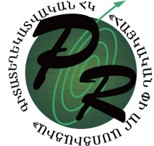
“Armenian PR association” scientific-informational NGO

PR cocktail for Youth Worker
Training Course
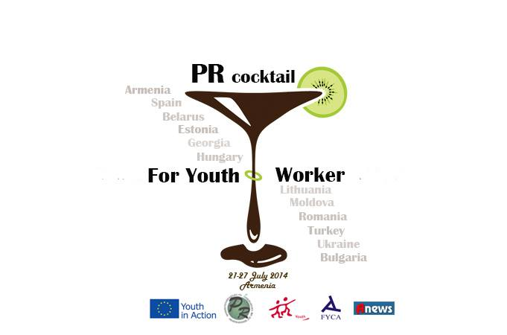

  - 20-28 July, 2014
  - Armenia, Yerevan

Country:
Organisation:
Name of the applicant:
Home address: Phone (private):
Phone (work/mobile):
Date of birth:
Sex:
E-mail:
Photo:
Dietary requirements (please list allergies or if you require vegetarian food, etc):

Other comments or requirements (such as wheel-chair access, etc):

Contact person in your home organisation (+ telephone and e-mail):

We would like to know the following…
1. What is your main role and responsibility in your organisation?

2. Your previous experience in the field of this TC

3. What is your personal motivation to attend this TC?

4. How you are planning to use your skills in your organisation?

***To be returned to prcocktailtc@gmail.com by the 21st of June ***

